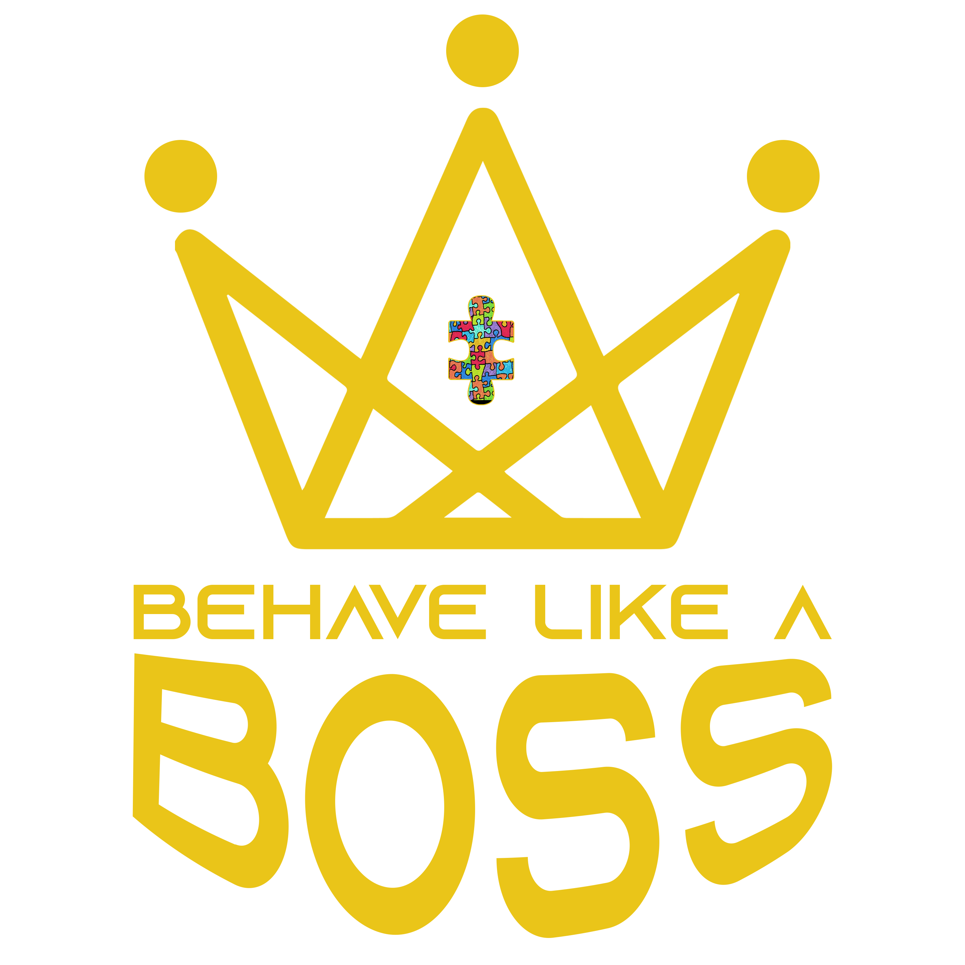

Behavioral Staff Observation

Pre-observation interview
How’s it going with this client? Questions/concerns about implementing the behavior plan?

On a scale of 1-5 (with 1 being the easiest and 5 being the hardest)
How is it to implement the plan? | 1 2 3 4 5
How is it to work with this client? | 1 2 3 4 5
How is it to collect data? | 1 2 3 4 5

Anything specific you would like me to observe today?

Observation
Problem BX | Observed? | Plan followed?
#1 | ☐ Yes ☐ No | ☐ Yes ☐ No
#2 | ☐ Yes ☐ No | ☐ Yes ☐ No
#3 | ☐ Yes ☐ No | ☐ Yes ☐ No
#4 | ☐ Yes ☐ No | ☐ Yes ☐ No
TOTAL Correct = # of BXs correct (yes)/# of BXs observed =

Replacement BX | Observed? | Teaching followed?
#1 | ☐ Yes ☐ No | ☐ Yes ☐ No
#2 | ☐ Yes ☐ No | ☐ Yes ☐ No
#3 | ☐ Yes ☐ No | ☐ Yes ☐ No
#4 | ☐ Yes ☐ No | ☐ Yes ☐ No
TOTAL Correct = # of BXs correct (yes)/# of BXs observed =

Skills | Observed? | Teaching followed?
#1 | ☐ Yes ☐ No | ☐ Yes ☐ No
#2 | ☐ Yes ☐ No | ☐ Yes ☐ No
#3 | ☐ Yes ☐ No | ☐ Yes ☐ No
#4 | ☐ Yes ☐ No | ☐ Yes ☐ No
#5 | ☐ Yes ☐ No | ☐ Yes ☐ No
#6 | ☐ Yes ☐ No | ☐ Yes ☐ No
#7 | ☐ Yes ☐ No | ☐ Yes ☐ No
#8 | ☐ Yes ☐ No | ☐ Yes ☐ No
#9 | ☐ Yes ☐ No | ☐ Yes ☐ No
#10 | ☐ Yes ☐ No | ☐ Yes ☐ No
TOTAL Correct = # of BXs correct (yes)/# of BXs observed =

TOTAL FIDELITY for this OBSERVATION =

Total Correct/Total Observed =

IOA on Data Collection
Problem BX | Agreements/agreements + disagreements = 1/1 = 100 % (no bxs observed)
Replacement BX | Agreements/agreements + disagreements = 15/19 = 79%
Skills | Agreements/agreements + disagreements = 26/28 = 93%
TOTAL IOA | Agreements/agreements + disagreements = 42/48 = 88%

Post-observation interview

How do you think the session went today?

Was there anything different today then when you are typically working with this client?
.

What did you feel best about in today’s session?

What concerned you/challenged you in today’s session?

KUDOS for (provide positive feedback from today’s session):

CONSIDER (provide specific feedback on how to improve):

What questions/concerns to you have about today’s session or my feedback?

What supports do you need to be the most effective behavior analyst?

NOTES TO LEAD:
(provide information about new problem behaviors you observed, any revisions for the behavior plan (problem bx, replacement bx, skills, bx strategies) you think should be considered, and any additional support staff may need as far as training or guidance).

Follow-up Actions Needed/by date | Follow-up Actions Completed/date

