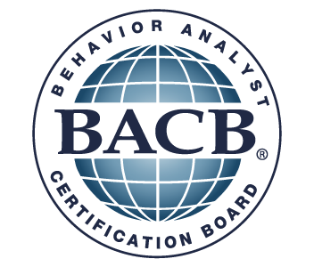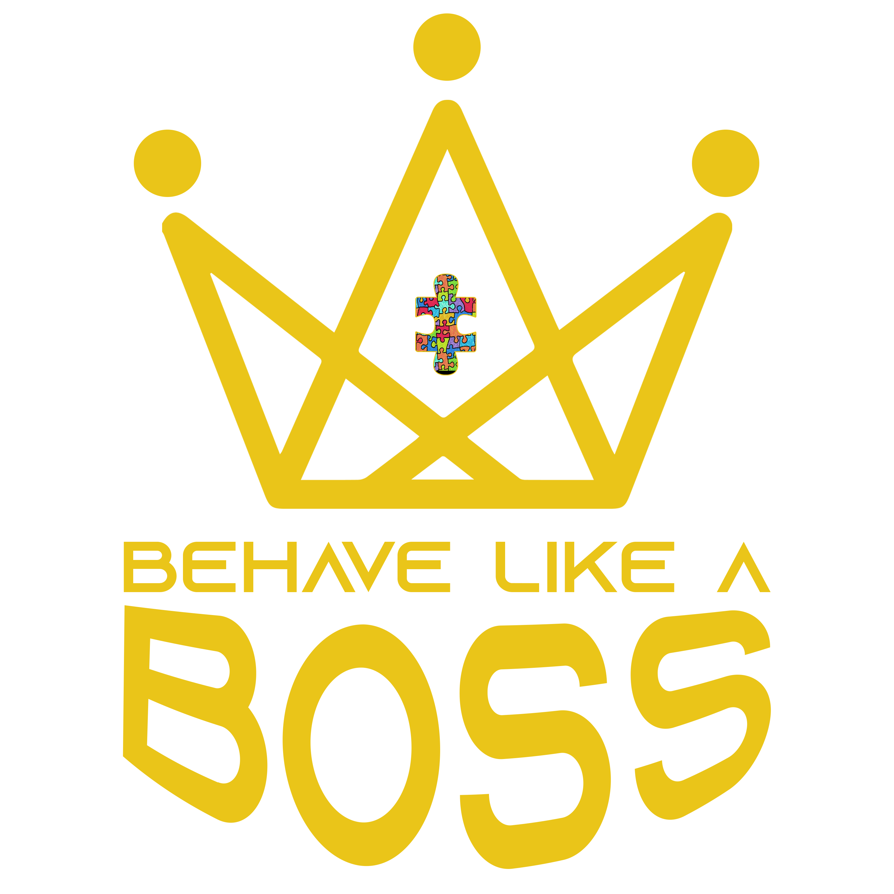

BACB Experience Supervision Form This form (or equivalent) must be completed at least once during each supervisory period.

Supervisee:____________________________ Supervisor(s):___________________________ Supervisory Meeting Date(s) & Duration(s):______________________________________________ Supervisory Meeting Format (check all that apply): _____ individual _____ group
This document covers the supervisory period from ____/____/____ to ____/____/____
Type of Experience (check one): __Supervised Independent Fieldwork __ Practicum __ Intensive Practicum

Experience Hours Accumulated During This Supervisory Period (complete all lines)
A) Number of independent experience hours accumulated (excluding time spent with supervisor): _____ B) Number of individual supervision hours accumulated: _____
C) Number of small-group supervision hours accumulated: _____
D) Total experience hours accumulated (add lines A through C): _____
Of the hours listed above, state the number spent in direct implementation of behavior-analytic programs: _____

Characteristics of Supervision Conducted During This Supervisory Period (check all that apply)
_____ BACB Task List skills covered (list Task numbers): ________________________________ _____ Specific client(s) discussed
_____ Client privacy protected
_____ Observation of supervisee (video)
_____ Observation of supervisee (in-person)
_____ Supervisory discussion & feedback (in-person)
_____ Supervisory discussion & feedback (remote)
_____ Readings: __________________________________________________________

Evaluation of Supervisee Performance:
S – satisfactory NI - needs improvement U - unsatisfactory N/A – not applicable
 | S | NI | U | N/A
Arrives on time for supervision
Maintains professional and courteous interactions with:
Clients/consumers
Other service providers
Coworkers
Maintains appropriate attire & demeanor
Initiates professional self-improvement
Accepts supervisory feedback appropriately
Seeks supervision appropriately
Timely submission of written reports
Communicates effectively
Written
Oral
Demonstrates appropriate sensitivity to nonbehavioral providers
Supervisee self-detects personal limitations
Supervisee self-detects professional limitations
Acquisition of target behavior-analytic skills

Overall evaluation of supervisee performance during this period (circle one): S NI U

Supervisee signature: ____________________________ Date: ___________________

Supervisor signature: __________________________ Date: ______________________
TO BE COMPLETED DURING EACH SUPERVISORY PERIOD – BACKDATED FORMS ARE NOT ACCEPTABLE

DO NOT SUBMIT THIS FORM TO THE BACB WITH THE EXAM APPLICATION
SUPERVISOR AND SUPERVISEE MUST EACH RETAIN A COPY OF THIS FORM FOR AT LEAST 7 YEARS FROM THE DATE OF THE LAST SUPERVISION MEETING

